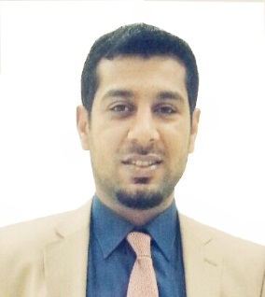
Curriculum Vitae

Name | birth place | Birth Date | Nationality
Duraid adel abdul razzaq | iraq / Baghdad | 9/11/1987 | iraqi
marital status | current residence | languages is speaks
Married | Baghdad | Arabic - English
Mobile |  | E-Mail
009647734433987 |  | duraid_irag@baghdadcollege.edu.iq

Present Address

Education

Certificate | University | year | Country | Major | Minor
B.Sc | Baghdad College of Economic Sciences University | 2008-2009 | iraq / Baghdad | Accounting
MSc | Baba.s.u | 2011-2012 | india | Accounting | Financial Accounting
Certificate of Teaching Methods  course | Salhaddin University | 2014 | Erbil | ــــــــــــــــــــــــــــ
Title | Salhaddin University | 2015 | Erbil | ــــــــــــــــــــــــــــ

